**7-3 Project Two: System Design Document**

Christine R. Emerson

Department of Computer Science, Southern New Hampshire University

CS-255: System Analysis and Design

Dr. Washington

February 15, 2023

# CS 255 System Design Document

## UML Diagrams

### UML Use Case Diagram

### UML Activity Diagrams

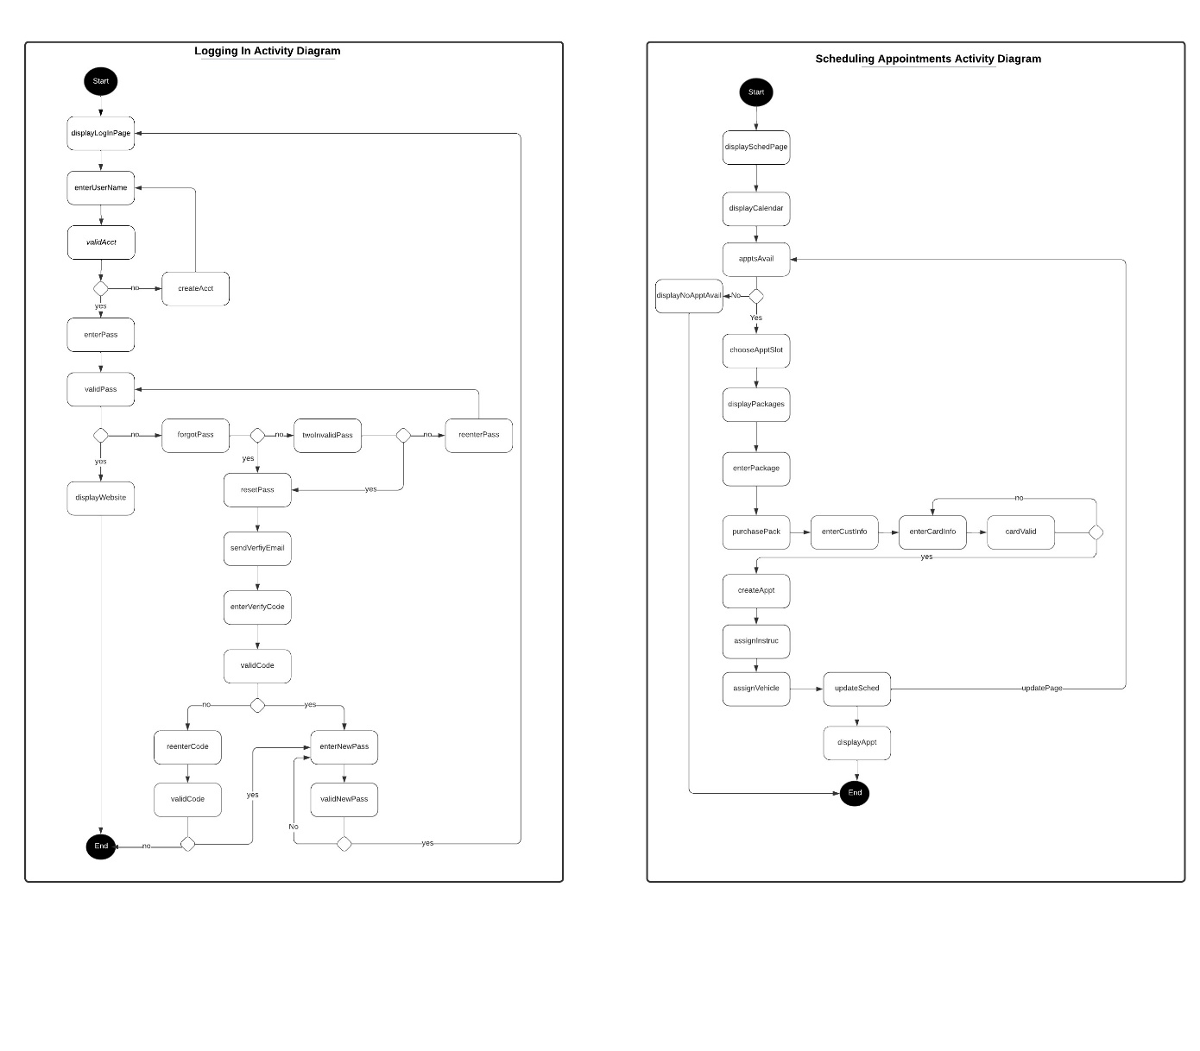

### UML Sequence Diagram

### UML Class Diagram

*[You were asked to create a class diagram based on the different classes and attributes needed for your system design. You are* ***not*** *required to include methods, but you may if you wish. Please insert your class diagram here. Check to make sure that you included appropriate components and symbols and that your design meets the client’s requirements.]*

## Technical Requirements

The DriverPass system must meet many technical requirements to function effectively. The system is designed to run on all platforms (Windows, Unix, Linux, etc.). Chrome, Edge, Firefox, and Safari are among the mainstream browsers considered for development. For the website to function on multiple software platforms, databases, network devices, and servers over the internet, cloud infrastructure is required as part of the system design. It is also necessary to have a physical infrastructure to support the hardware components, including networking equipment, routers, firewalls, and backup devices. Hardware resources are required to connect servers and virtualized resources. Cloud storage allows data to be stored and accessed through the internet. Cloud networks are physical resources such as routers, switches, and wires. They are made up of *multiple subnetworks to create VLANS (local virtual networks).* In cloud computing, the infrastructure refers to the hardware, storage, networking, and application software that form the basis for the cloud-based application.

For the website to continue running without interruption, MySQL and cloud SQL will be implemented to ensure the databases are secure and scalable. Encryption keys are integrated into the system for automatic data protection at rest and in transit. This application will use these databases to manage user account information and drive appointments. The Google Analytics service will provide real-time tracking of reservations, traffic metrics, visitor location, device type, new vs. returning users, and activity reports for offline viewing.

Data and applications are accessible from anywhere and on any device, making security protocols more critical. Multi-factor authentication will add additional layers of protection to help prevent security breaches. The system will assign roles to each user, and each user must have a unique username and password. Different users will have different levels of access to the system as a result of role-based authentication. A single sign-on token will also be accepted in the design, simplifying users' and administrators' management of usernames and passwords. If someone tries to log in more than three times without success, users will be notified to change their password. The system will also include authentication methods so users can reset their password if they forget it.